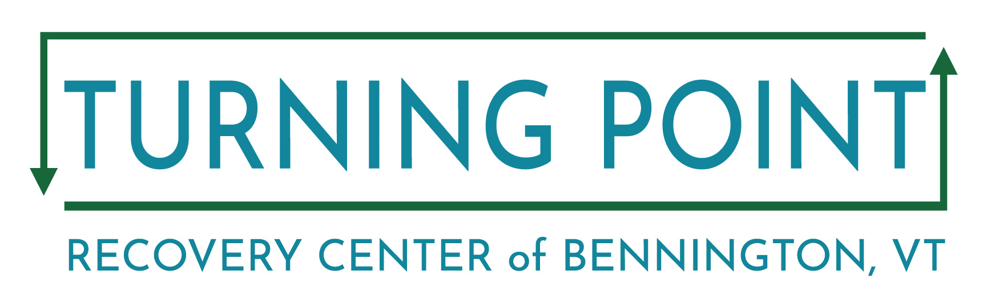
Impaired Driver Rehabilitation Program (IDRP)
IDRP Program Guidelines – Intensive Program and Non-Intensive Program
The Bennington IDRP program has two options for the IDRP Education and Evaluation program. The programs are for people with first and second offenses seeking reinstatement of driving privileges, as well as court ordered participants

All IDRP classes are conducted online via Zoom.
Here are the 4 basic steps:
- Print & Mail-in your registration packet and fees. Complete and mail the registration material found below on this website (www.tpcbennington.org) along with your payment ($400) and mail to: Laura Payne, IDRP Registration, P.O. Box 454, Bennington, VT 05201
If unable to print the IDRP registration packet from the website, please call the Turning Point Center (802 442-9700) to request it through the mail or stop by in person.
A total registration fee of $400 (bank check or money order), made out to Turning Point, is due with your mail-in registration. We are unable to accept personal checks or debit/credit cards. Once we receive your registration, we will obtain your driver abstract and mail your class workbook. Please submit your registration at least 10 business days before the class begins.
- Completion of a Drug and Alcohol Screening: The IDRP Evaluator, Kristi Pepoon, will call to schedule the Intake Evaluation and provide more detailed information about the program. You cannot be placed on the class roster until your intake is scheduled. The treatment requirements for license reinstatement are provided to the client by the IDRP Evaluator. For first offenders, if treatment is determined to be necessary by the IDRP evaluator, treatment must consist of a minimum of four (4) hours in no fewer than four (4) weeks. Treatment must consist of a minimum of four (4) hours in no fewer than four (4) weeks. Clients with two or more convictions (including clients with life suspensions who are completing the Total Abstinence application) must complete 20 hours of treatment over a minimum of 24 weeks. Please note that these are the minimum requirements. You are responsible for contacting the treatment provider. Please see our list of recommended providers on our resource page.

- Completion of the IDRP Education Component: Participants with first and second offenses are required to complete the education component, either through the weekend intensive program or the 2-week Tuesday/Thursday evening program. An hour lunch break is included in the weekend program.

- Completion of an exit interview (if required), with the IDRP evaluator once the IDRP education component has been completed and the required treatment completion forms are faxed or sent to Kristi Pepoon, IDRP Evaluator.

Three Forms Needed for Mail-In
We ask you to please have your paperwork mailed to us no later than one week before the class begins. Early registration is recommended to reserve your spot.
- Evaluation Information – Fill out the top section, from your signature up. PID is your license # or photo ID #. Make sure you include your mailing address.
- Release of Confidential Information – Please fill out your name and date of birth on top and sign and date on the bottom. Include your email. Include additional contact names, addresses, and fax numbers that you will need your completion forms sent to.
- Expectations for Participants/Participant Agreement – Sign and add your 1st and 2nd class preference at bottom.
Other requirements or suspensions may need to be satisfied before your privilege to drive can be reinstated. In these instances, contact the Vermont DMV at (802) 828-2050, fax: (866) 272-7989.
Contacts
Laura Payne, IDRP registration, Turning Point Center/Bennington (802) 442-9700
Kristi Pepoon, IDRP Evaluator, (802) 733-5566/fax (802) 753-7052
IDRP Central Office – Burlington, VT (802) 651-1574/fax (866) 272-7989
Ignition Lock DMV (802) 828-2061
Vermont State website of IDRP Programs: https://www.healthvermont.gov/alcohol-drugs/services/impaired-driver-rehabilitation-program

IDRP PROGRAM – Provider: The Turning Point Center/ Facilitator: Teri Atwood -Bennington, VT
Evaluator: Kristi Pepoon, LICSW – LADC – 802-733-5566/fax 802-753-7052 Expectations for Participants – For Zoom Class
Participants must be on time for class, have no distractions and be in a confidential space. Tardiness may result in dismissal from IDRP. Participants must attend all sessions and be free of alcohol and drugs. Participants attending class/orientation or intake under the influence of alcohol or drugs can be dismissed from the course.
Participants are required to attend all education component classes for a total of ten (10) hours. These classes must be attended in sequential order. Participants are required to complete all assignments, maintain the confidentiality of others in their class, and must come prepared to each class. For Zoom classes video & audio must be on. This includes having the assigned workbook at each session. If a participant has the PDF they must have it on a separate device so that their audio/visual is not interrupted. Participants must contribute in small group discussions, complete assignments, and demonstrate knowledge of the information presented. Participants may be dismissed from the course for offensive behavior at the discretion of the facilitator.
If the participant fails to complete the initial course for which they are registered, they can re- enroll for one more class at the same location for no additional cost. They need to contact the program when they are ready to begin the class to make sure there is space.

Cancellations and Excused Absences
The following circumstances and criteria are the guidelines for potentially excusable absences for participants, which can be at the discretion of the IDRP Provider:
- Medical emergency—with documentation
- Death in the immediate family
- Other emergent situations were determined with the discretion of the IDRP Manager.
If the participant has signed up for the Education Component and they need to cancel, they may do so up to 24 hours before the start of the program.
In rare cases, the IDRP Provider may need to cancel a class due to severe weather or other unforeseen circumstances. A notice (either by phone or text message, to be determined by the provider) will be sent to the participants no later than four hours before the class start time. The provider is responsible for collecting a means to communicate with the participants in case of an emergency. The IDRP Provider will be responsible for rescheduling the missed class.
Participant Signature_________________________________ Date_______________________ 1st choice for class date:____________________________/ 2nd choice ____________________
Vermont Impaired Driver Rehabilitation Program Evaluation Information

First Name: |  | Middle Initial: |  |  | Last Name:
Date of Birth: |  | Phone: |  |  |  | VT PID:
Address:
Education Level: Employment:

Type of Offense | Date of Offense | BAC for Offense
By signing this form, I am attesting that all the information that I provided is true to the best of my knowledge and that I must complete the IDRP in it’s entirety within five (5) years from today’s date or will be required to start the Program over and pay all applicable fees.
Client Signature: Date:
Evaluation Information (To be completed by IDRP Evaluator)

Location of IDRP Evaluation: |  |  |  |  | Date of Evaluation:
DAST Score: |  | AUDIT Score: |  |  | Offender Type:
Approximate time since last use: |  | Alcohol: |  |  | Drugs:
Clinician Comments:
Brief History of Substance Use: Present Use:
Family History:
Additional Comments or Areas of Concern (including information about participation in IDRP Education Program): Evaluator expectations for IDRP clinician:
Exit interview required? Yes No
By signing this form, I am attesting that all of the information that I provided is true to the best of my knowledge.
IDRP Evaluator Signature: |  | Date:
License #:

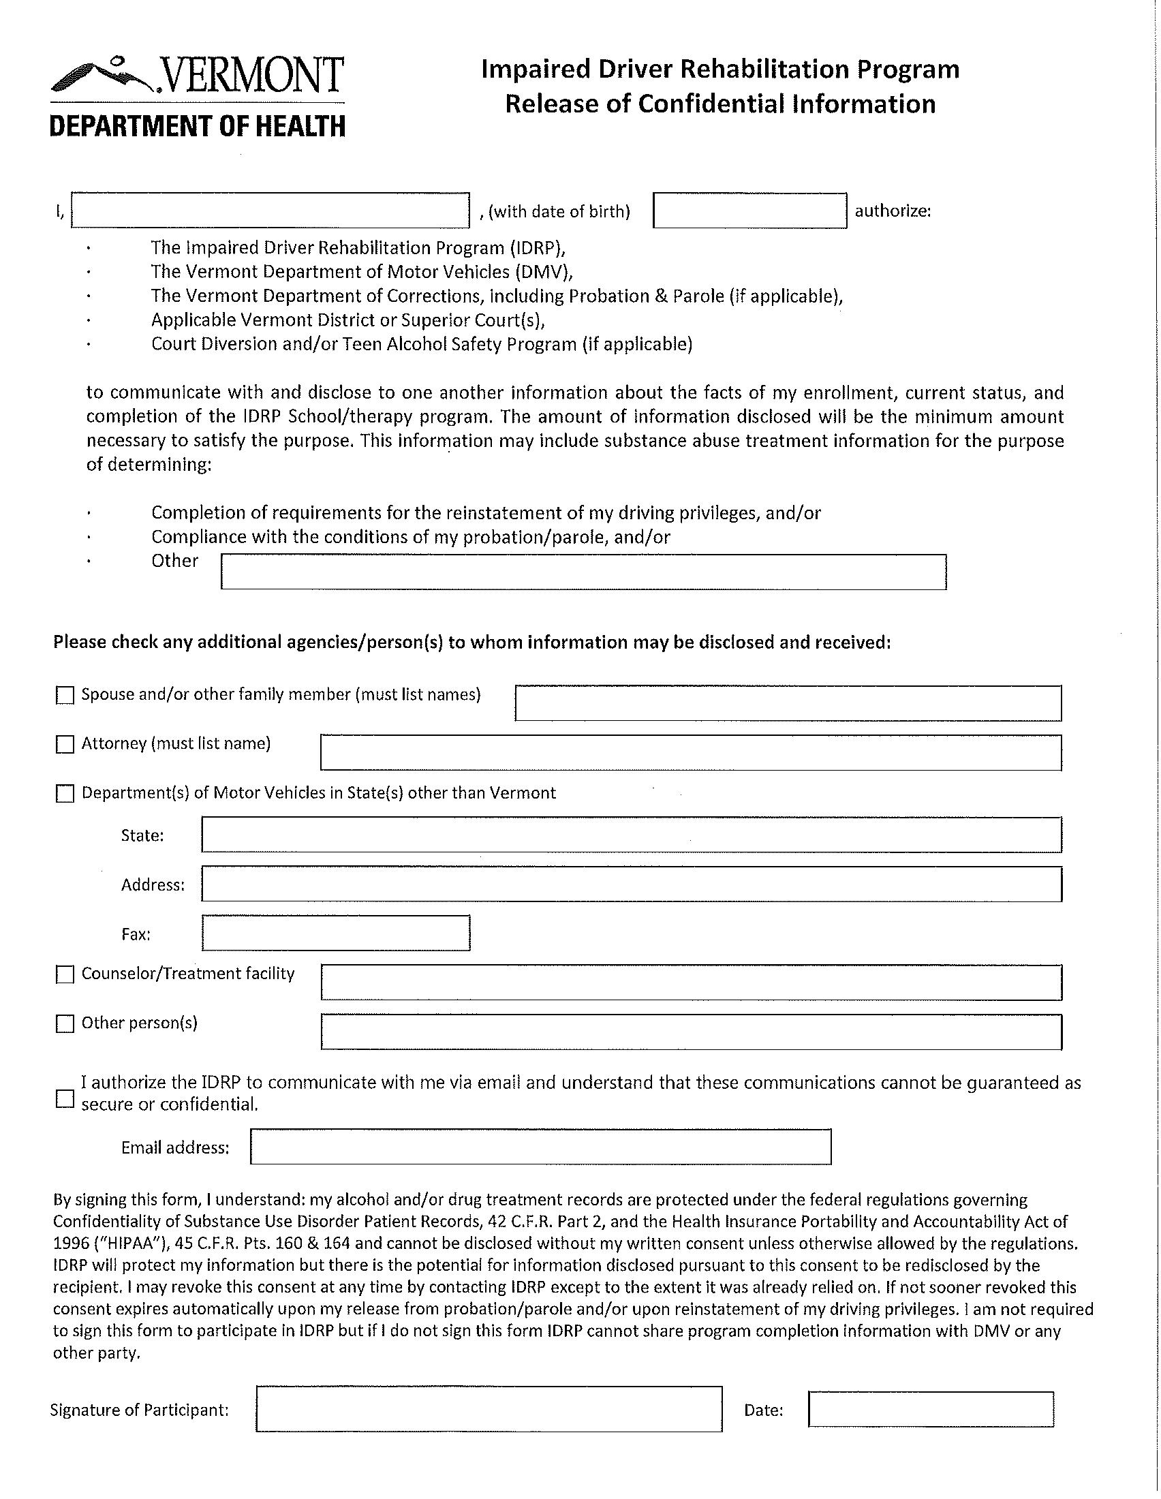

People with life suspension will need to complete an IDRP evaluation and treatment More information about applying for the total abstinence process with DMV can be found at: https://dmv.vermont.gov/licenses/suspensions/total-abstinence

